**Detailed Python Installation Instruction**

This document is made based on assumption that the reader doesn’t have Python installed and is unfamiliar with the installation and command line.

For simplicity, this document would only provide information for the installation of Python 3.5 under a fix path “C:\Python35-32”.

1- Download and install Python.

* Copy the URL “<https://www.python.org/ftp/python/3.5.4/python-3.5.4.exe>” to a browser address bar. Alternatively, Ctrl+Click the above link.
* Choose a directory to save the installer and start downloading.
* Once finished, run the installer “python-3.5.4.exe” as administrator:

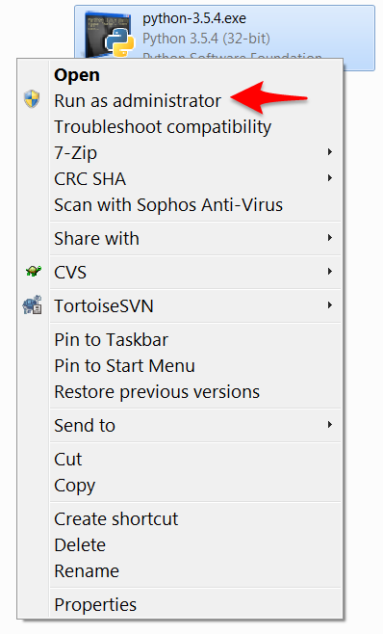

* In the wizard, check “Add Python 3.5 to PATH”:

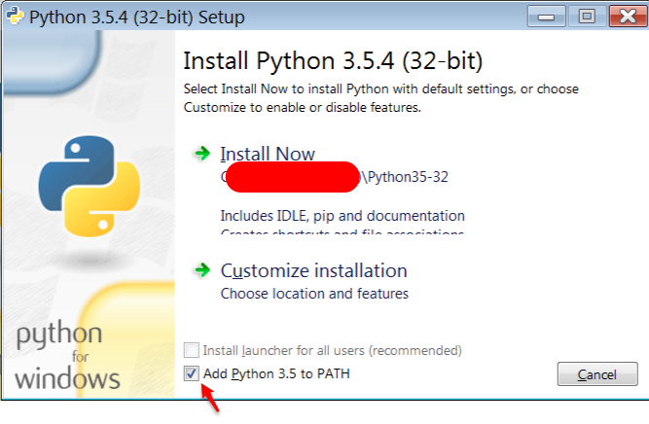

* Change the location for installation by first clicking “Customize installation”:



* Click on “Next” (and keep all settings as default):

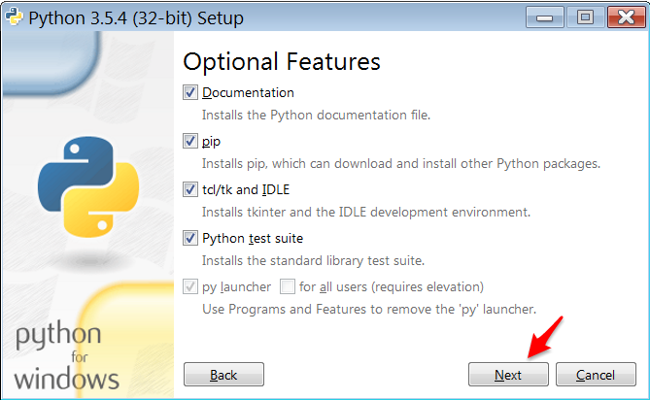

* Enter the new location “C:\Python35-32” here:

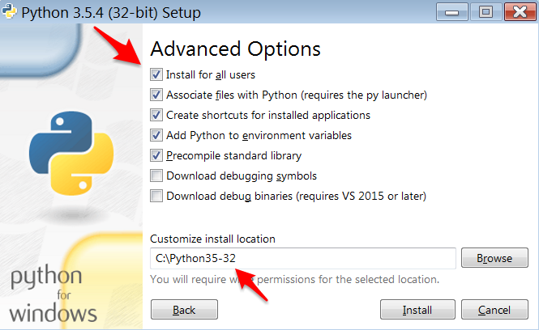

* Start by clicking “Install”.

2- Install the required Python packages.

* Double-click the batch file (get_packages.bat) in the same folder.

3- Run the StrokeAggregator by double-clicking “stroke_aggregator.py” in the top folder strokeaggregator.